**Debt Securities**

1. Types of Securities and Yields

* **Zero Coupon Bond (also called discount bond)**

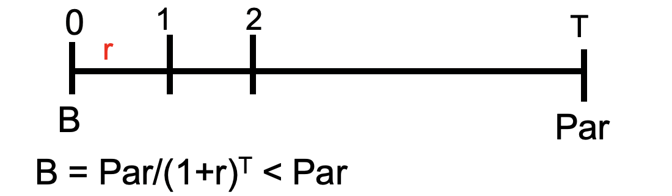

r = opportunity cost

= YTM on similar risk bond

**Concept 1: YTM**  **►YTM = (Par/B)1/T – 1**

Expected return from buting now and holding till maturity ~ assume no bankruptcy

YTM= RF+ Risk Premium (default, call, liquidity, maturity...)

e.g. Bonds with higher risk of default: Junk bond

**T-bill** Zero Coupon security with maturity ≤ 1-year

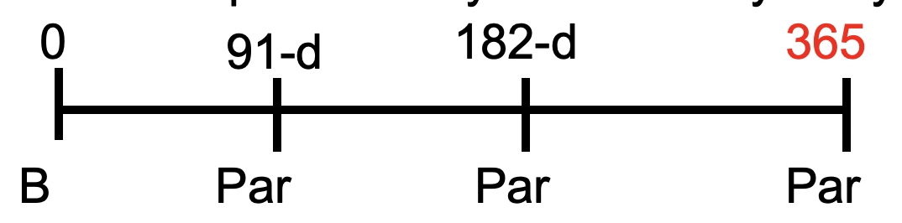

* **Bank discount yield Y0**

capital gain

underestimate, but not means lower return

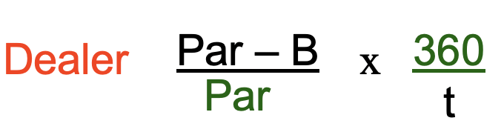

days left to maturity

* **Bond Equivalent Yield YBEY**

APR

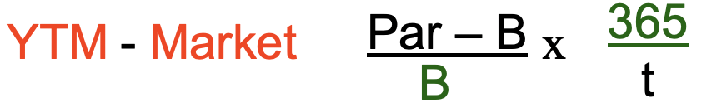

* **Effective Annual Yield YEAY**

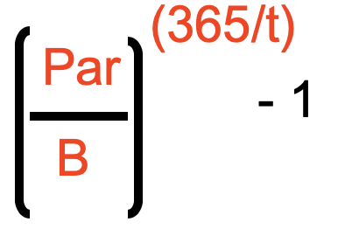

<Example 1>

B0=90 Par=100 Mat =1 year

BDY: (100-90)/100*360/365=9.86%

BEY: (100-90)/90*365/365=11.11%

EAY: (100/90)365/365-1=11.11%

<Example 2>

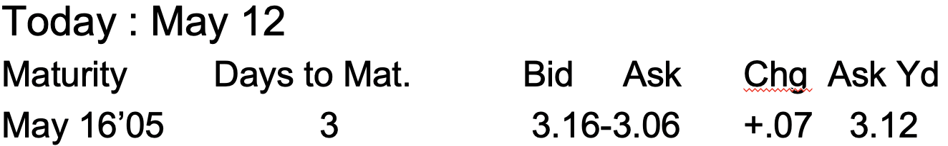

YBEY

%

t

don’t count

the last day

YD

Yield goes up, price goes down

🡪 Bad news

B=Par(1-YD*t/360)

The spread should always be positive

* **Standard Coupon Bond**

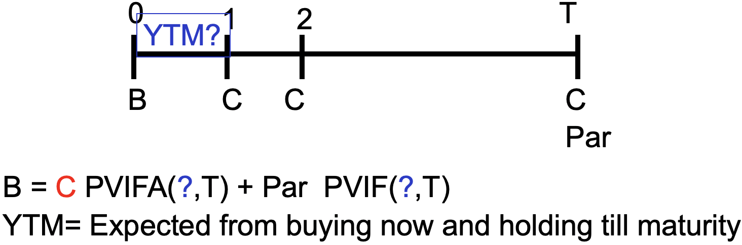

* Trial and error
* Financial calculator
* Excel =Rate(Nper, Pmt, PV, FV)
* Approximation

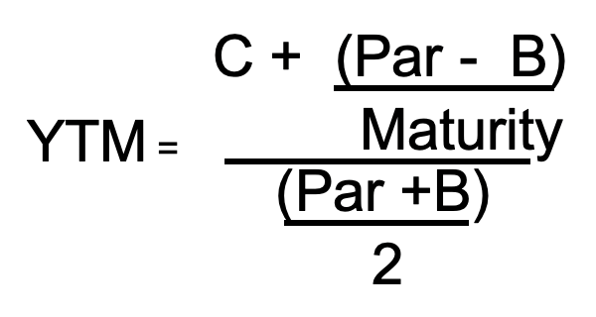

capital gain/loss yield

coupon yield

**Concept 2: Annual Realized Rate**

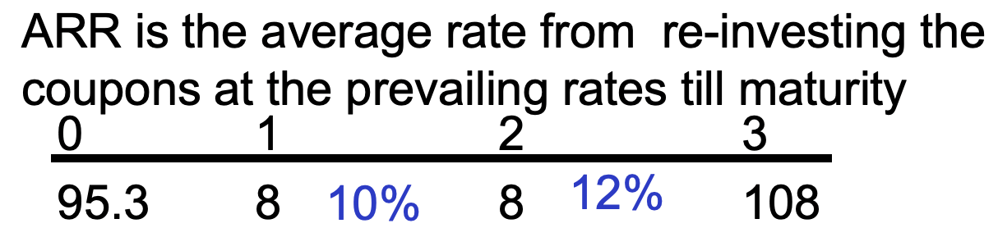

HIV (Horizon Investment Value)

Par = 100

All coupons = 24

Interest on interest=8(1.1)(1.12)+8(1.12)-16 = 2.816

-------------------------

= 126.816

Re-investment R.O.R = (126.816/95.3)1/3-1=0.1

**Concept 3: Holding Period Return (HPR)**

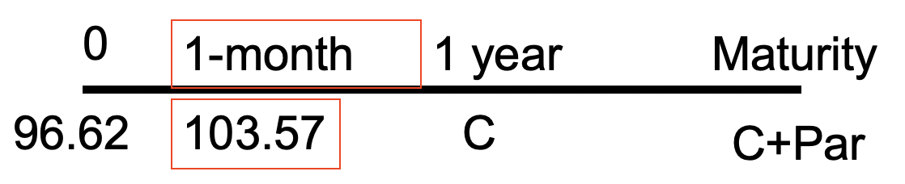

HPR=(103.57-96.62)/96.62=0.0719

BEY=0.0719*12=0.8628

EAY=(1+0.0719)12-1=1.3

2. Pricing Method

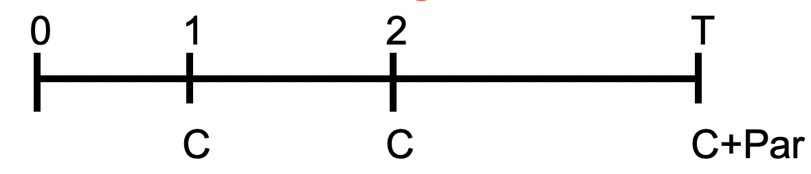

0r2

0r1

0rT

discount rate(could use T-bill)

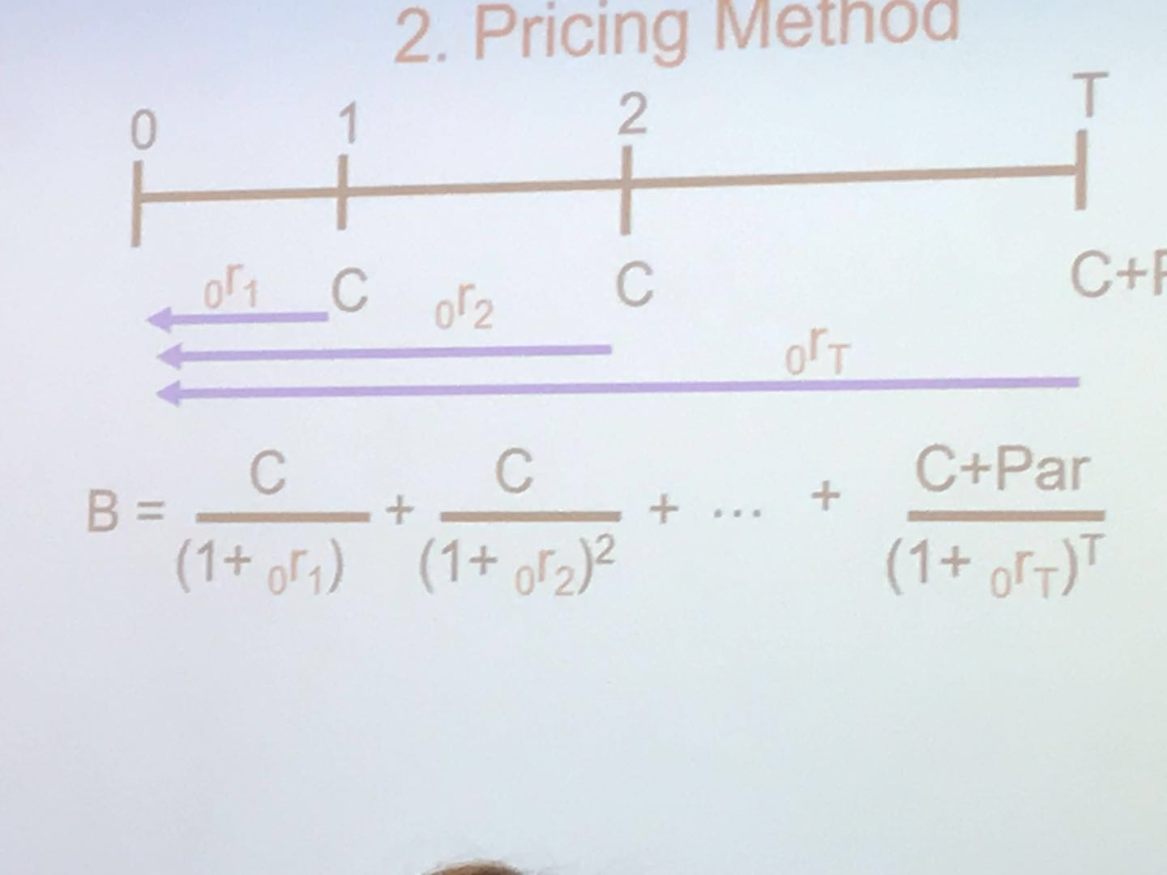

YTMs on zero coupon rate is called spot rates

**Method 1 Use Similar risk ZCB**

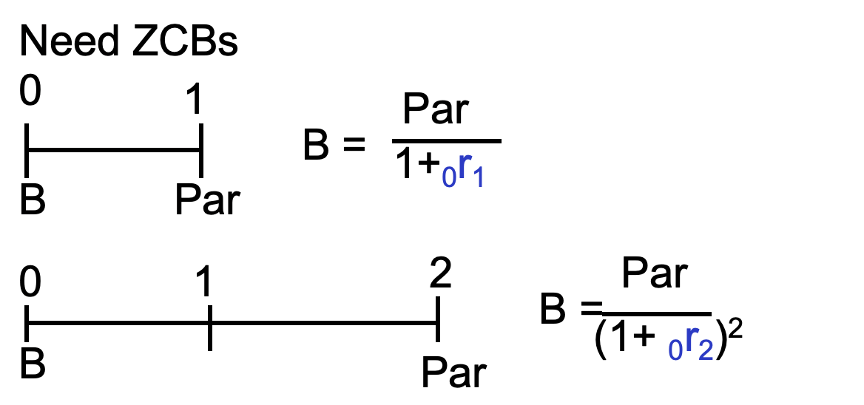

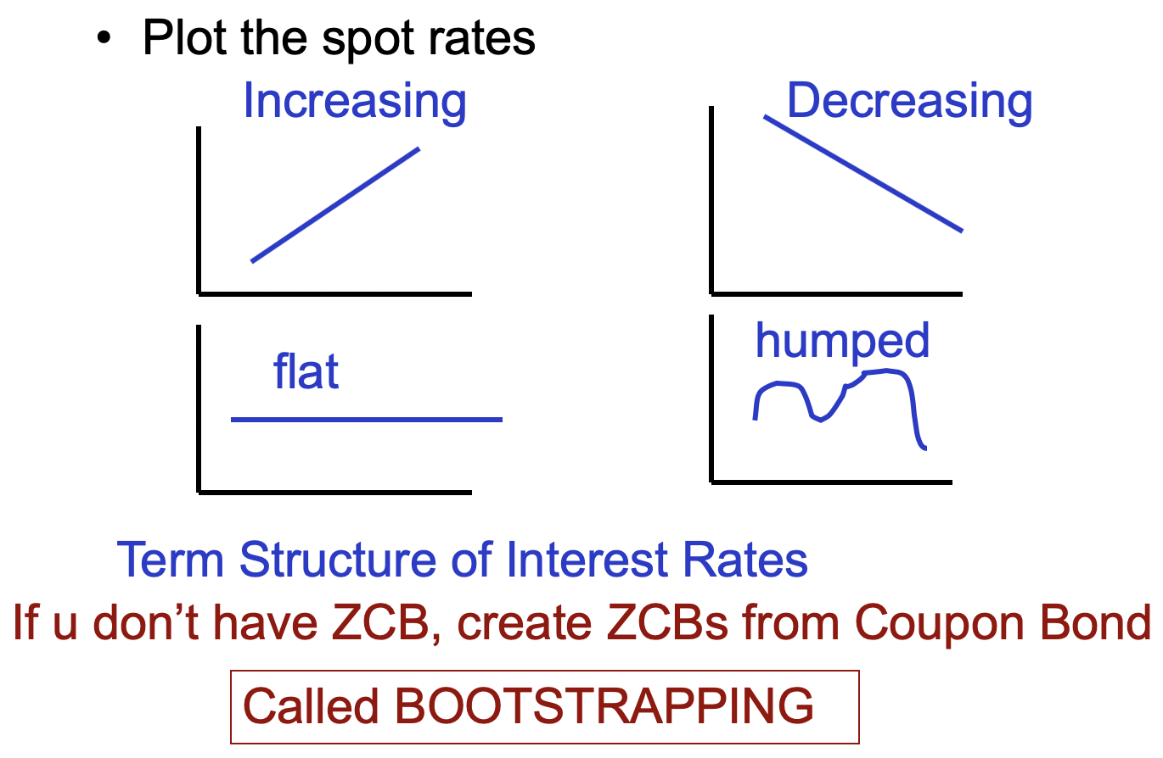

normal

Yield Curve

<Example 3>

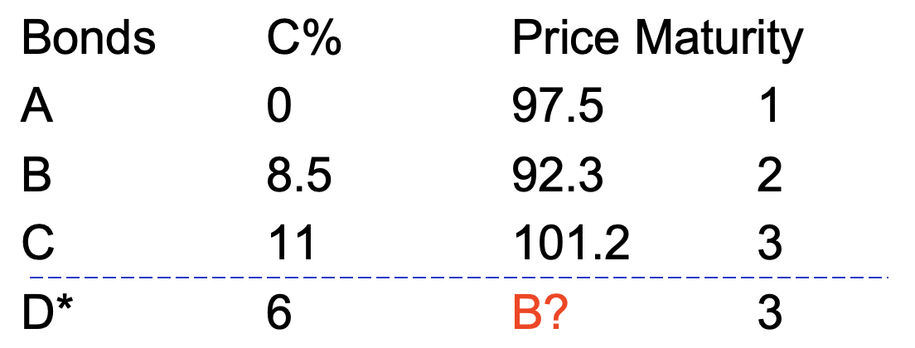

**Method 2 Cash Matching**

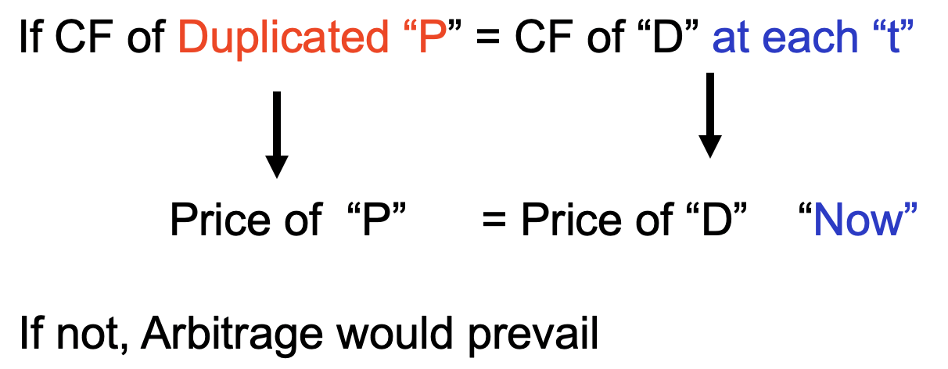Pricing under no arbitrage (One Price)

|  |  |  |  |  |
| --- | --- | --- | --- | --- |
|  | A | B | C | D |
| Year 1 | 100 NA | 8.5 NB | 11 NC  = | 6  = |
| Year 2 |  | 108.5 NB | 11 NC | 6 |
| Year 3 |  |  | 11 NC | 106  = |

NC = 0.955 NB = -0.0415 NA=-0.0415 NOT weights, N is number of shares

PD=97.5(-0.0415)+92.3(-0.0415)+101.2(0.955)=88.7 overpriced

Arbitrage opportunity: Short sell D. Buy duplicated portfolio in the above proportions to make a profit of 0.3 till equllibrium

3. Interest Rate risk

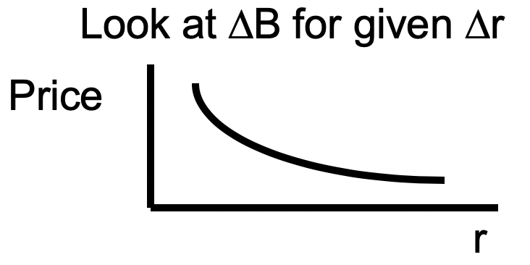

There are 2 impacts as rates increase

Price decreases 🡪 Price risk

Re-invest coupons at higher rate 🡪 re-investment risk

**Hedging** interest risk ≈ offsetting those risks

**A. Macaulay Duration**

►Weighted average maturity of cash flows where the weights are the PV of CF

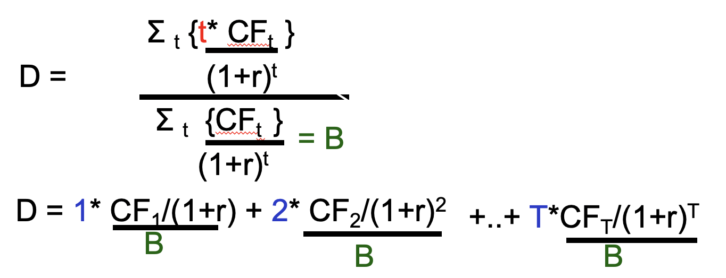

ZCB 🡪 DZCB = T years More risky!

Coupon bond 🡪 DCouponBond < T years

**Interest Rate Risk Model**

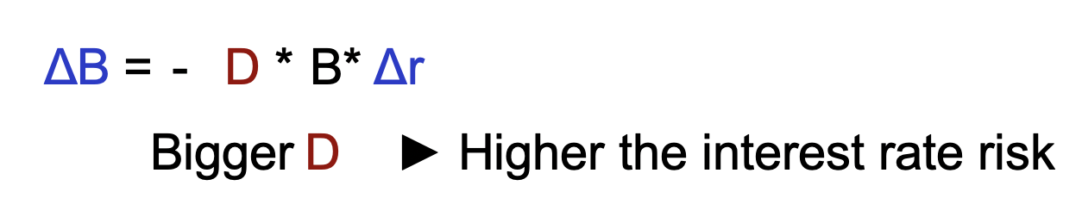

dollar value

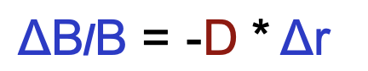rate

<Example>

10% Bond , Current Price =$100, T=2 yrs

D = (1*10/1.1)/100+(2*10/1.12 )/100 = 1.9 < 2

Interest rate risk if Δr = + 5% ?

ΔB/B = - 1.9 * 0.05 = - 9.5%

ΔB = -0.095 * 100 = - $ 9.5

to new B = $90.5

**Modified duration**

MD= D/(1+r)

ΔB = - MD* B*Δr

ΔB/B = - MD* Δr

<Previous example>

ΔB/B = - 1.9 /1.1 * 0.05 = - 8.6%

ΔB = -0.086 * 100 = - $ 8.6

to new B = $ 91.4

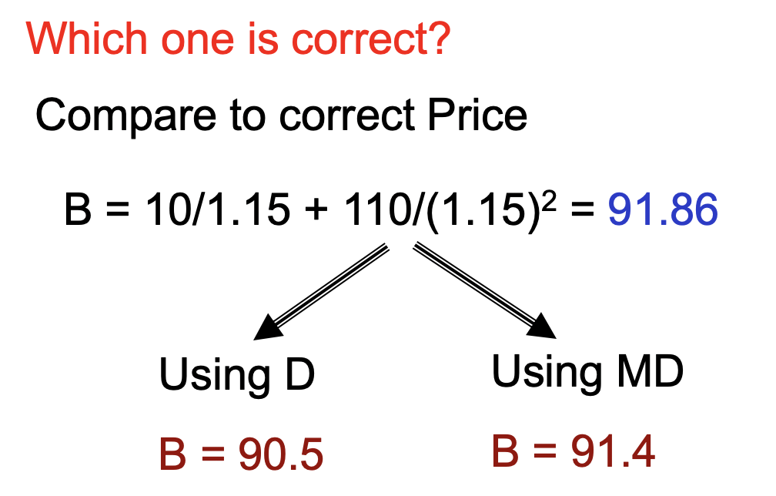 Modified duration is better!

**B. Convexity**

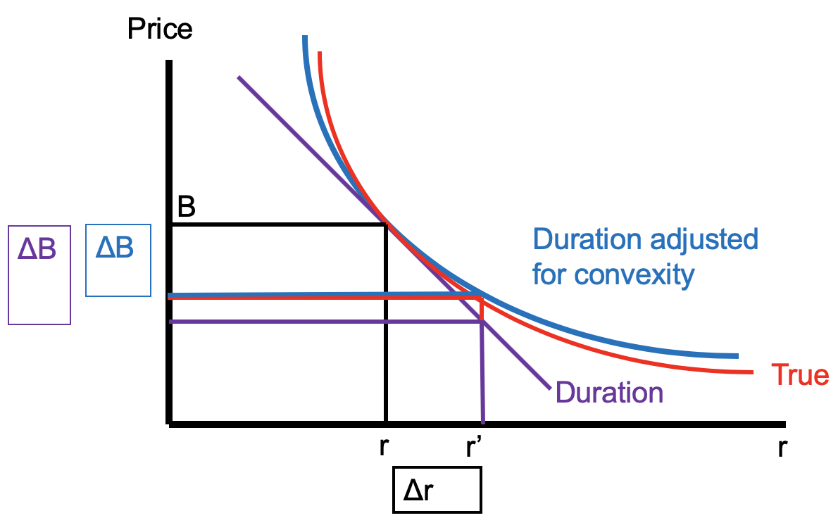

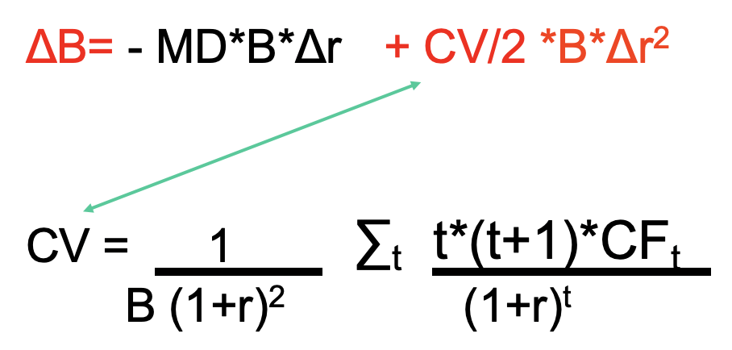

<Revisited Example>

CV =

ΔB = -MD*B*Δr + CV/2 *B*Δr2 = -1.9/1.1*100*0.05 +4.64/2*100*0.052 = $-8.02

to new B = $91.98

Compare the predictions

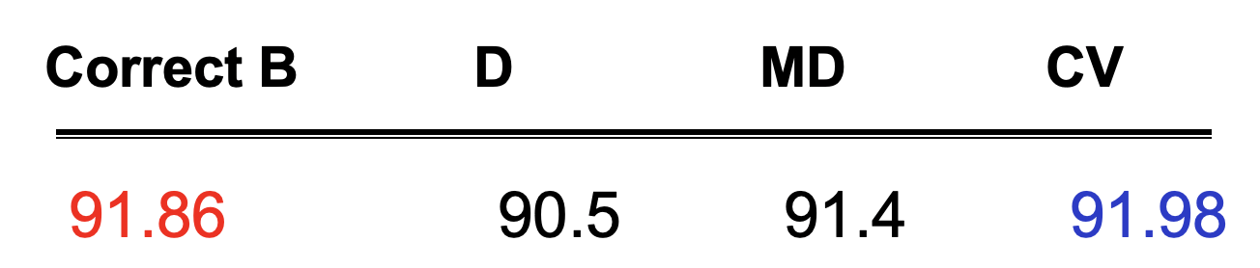

4. Immunization

*It involves finding a portfolio that produces a stream of cash flows that match up exactly with the stream of liabilities*

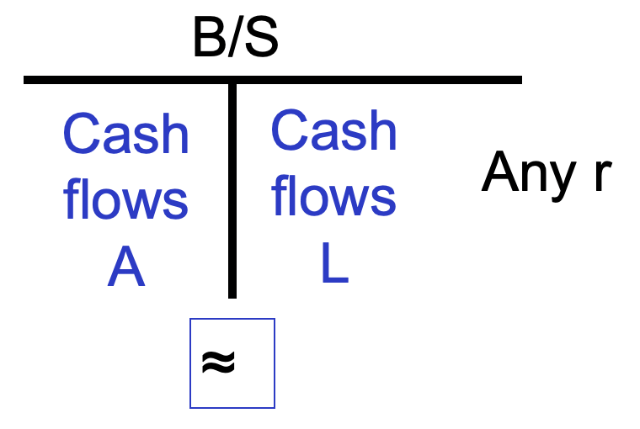

Consider a pension fund manager

* Minimum condition

Value of the Assets **≥** Value of Liabilities

But the manager is also affected by two types of risk :

Price risk

Re-investment

These are offsetting risks, if duration of assets = duration of liabilities

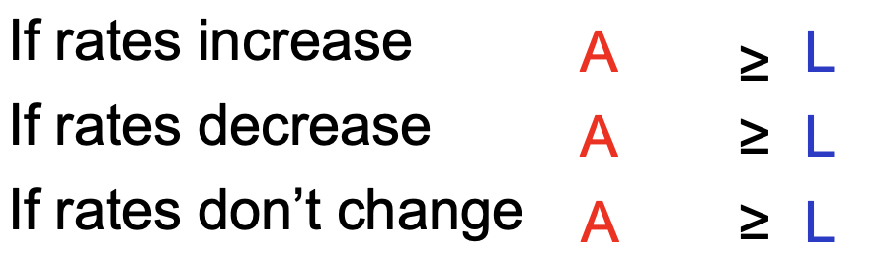

<Example>

Liability

Single payment of $1,931 in 10 years

The current interest rate =10%

PV (liability) = 1,931/(1+.1) 10= $745

Duration (liability)= 10

You have the choice between

* 20-year 7% coupon bond with r =10% ---- D=10 😀
* 8-year zero-coupon bond --- D=8 😟

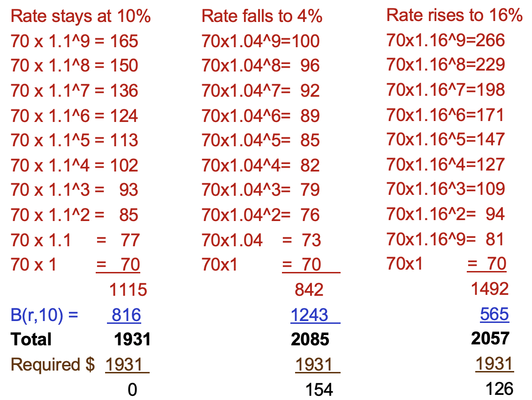

price risk

re-investment

risk

<Example>

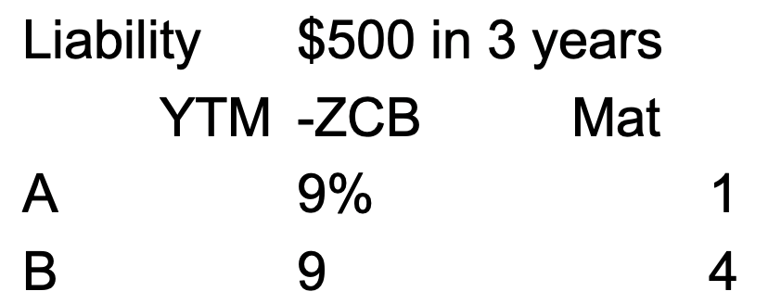

Q1: How much should you put aside to cover the liability?

PV= 500/1.093 =382.09

Q2: How many bonds of each kind you should buy to cover the liability and hedge against interest rate risk?



XA*DA+XB*DB=DL

XA 1 +XB 4 = 3 🡪 XA =1/3 XB = 2/3

Number of A is 382.09*1/3/ [100/(1+0.09)]= 1.38 (reinvested every year --- reinvestment risk)

Number of B is 382.09*2/3/ [100/(1+0.09)4]= 3.56 (sell before maturity --- price risk)